EXPERIMENT 12- VIEW QUERY DBMS
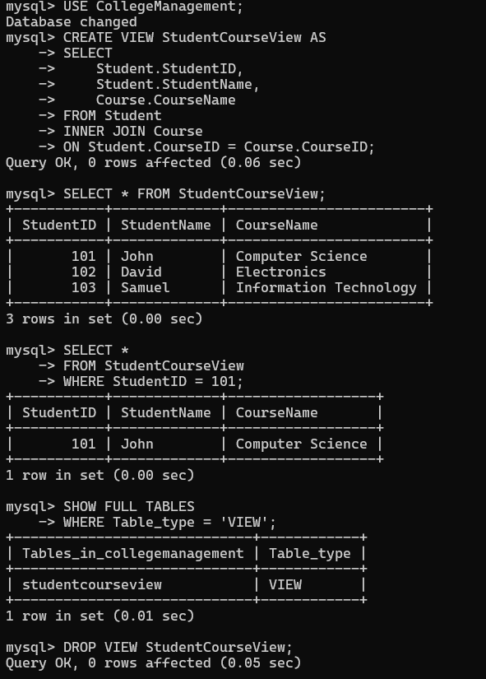
VIEW

